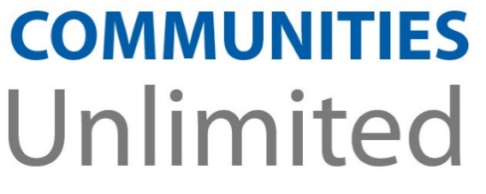

Alabama RCAP/AWWA Workshop
Small System Operator Training: Achieve and Maintain Compliance with SDWA

November 12, 2020
Online

8:00 SDWA Workshop Introduction & Pre-Test
Disinfection Overview
Distribution By-Products (DBPs)
Distribution System Infrastructure
12:00 Lunch
1:00 Distribution Water Quality
Large Building (Schools, Hospitals)
America’s Water Infrastructure Act
4:45 Questions, Post Test & Evaluations

Speaker: Dinah Foreman, Communities Unlimited

This training will provide 7.5 CE hours toward water certification renewal contingent upon
approval by ADEM.

Training is provided at no charge by Communities Unlimited, Inc., Rural Community
Assistance Partnership (RCAP), and American Water Works Association (AWWA) through
funding provided by the U.S. Environmental Protection Agency.

Register Online: http://events.constantcontact.com/register/event?llr=pcbhpwn6&oeidk=a07ehcfjpepb12af85c
Or Call for Information: Communities Unlimited – Dinah Foreman 256-483-8611 or Alfred Jackson 334-467-4786
AL/MS AWWA – Lindsay Wright, AL/MS AWWA 334-538-4706

