***2021 Alabama/Mississippi Section of AWWA Awards Announcement***

**Request for Applications and Nominations**

Completed Applications are to be submitted ELECTRONICALLY on or before **May 31, 2021** to Maggie Wei, P.E. at the following email address: [maggie.wei@waggonereng.](mailto:maggie.wei@waggonereng.)com.

If you **DO NOT** receive confirmation of receipt of this application within one week, please contact Maggie Wei by phone at (601) 317-5025.

**Deadline to Submit Nominations is May 31, 2021**

**Treatment Plant of the Year Award**

Eligibility Requirements:

* The Treatment Plant must be operated by a Utility OR employee of a utility that is a member and in good standing with the AL/MS Section of AWWA.
* The Treatment Plant must be in compliance with all regulatory agencies.
  + points will be deducted for water quality violations.

**Distribution System of the Year Award**

Eligibility Requirements:

* The Distribution System must be operated by a Utility OR employee of a utility that is a member and in good standing with the AL/MS Section of AWWA.
* The Distribution System must be in compliance with all regulatory agencies.
  + points will be deducted for water quality violations.

**Young Professional of the Year Award**

Eligibility Requirements:

* The Nominee must be under 35 years of age OR have less than 10 years of experience in the water industry.
* The Nominee must be a member OR employed by a member utility/company and in good standing with the AL/MS Section of AWWA.

**Operator of the Year Award**

Eligibility Requirement:

* The Operator must be a member OR employed by a member Utility and in good standing with the AL/MS Section of AWWA.

***RECOGNIZE MEMBERS AND EMPLOYEES***

***FOR***

***THEIR EXCEPTIONAL WORK AND CONTRIBUTIONS IN THE WATER INDUSTRY***

The AL/MS Section will select a Plant, Distribution System, Operator, and Young Professional from Alabama and Mississippi whose outstanding performance during the preceding year merits special recognition by the Section. All forms are available for download under the Awards Section of our website ([www.almsawwa.org](http://www.almsawwa.org)). **Submission Deadline is May 31, 2021.**

***Alabama/Mississippi Section of AWWA***

**Water Distribution System of the Year Award 2021 Requirements**

**Purpose:**

The Awards Committee is charged with the selection of one distribution system from Alabama AND one from Mississippi whose outstanding performance during the preceding year merits special recognition by the Section. Recipients of the award will have demonstrated that it performs quality water system maintenance procedures through the efficient use of labor, materials, equipment, and innovative methods to keep its distribution system in good working condition to minimize health hazards.

**Procedure:**

The Committee will receive applications until **May 31, 2021**. The **ENTIRE** application **cannot** exceed **10** pages, otherwise **penalty points** will be **deducted**. Following the application deadline, the Committee may evaluate each applicant through requests for additional information and/or an evaluation of the utility by way of a site visit. The Committee shall make their own selection, using their best judgment of the utility, based on additional information requested and/or the evaluation completed while visiting the utility. The award shall be presented at the **2021 AL-MS Water Joint Annual Conference.**

**Eligibility:**

In order for your Utility to qualify for the **Water Distribution System of the Year Award**, it must meet the following minimum requirements:

* The Utility OR an employee of the utility must be a member in good standing with the AL/MS Section of AWWA.
* The Utility must be in compliance with all regulatory agencies.
  + points will be deducted for water quality violations.

**Distribution System Evaluation Criteria**

Systems will be graded on the criteria below. Site visits may be required for obtaining portions of the criteria listed below. Please remit the following information in essay form or a brief description for consideration. Pictures may be attached as deemed necessary. Additional pages may be added to the application as needed. However, the **ENTIRE** application **cannot** exceed **10** pages, otherwise **penalty points** will be **deducted**.

* Performance Measures (including, but not limited to, water quality; main breaks/leaks; service breaks/leaks; water loss; incidents of pressure loss within system/boil water notices; record of NOVs; and response procedures)
* Operational Recordkeeping/Regulatory Compliance
* System Maintenance Program
* Operator/Personnel Training Program
* Safety Program/Safety Guidelines
* Cross Connection/Control Program
* Meter Testing Program
* List of Milestones or Accomplishments in the past year

**2020 WATER DISTRIBUTION SYSTEM OF THE YEAR WINNERS**

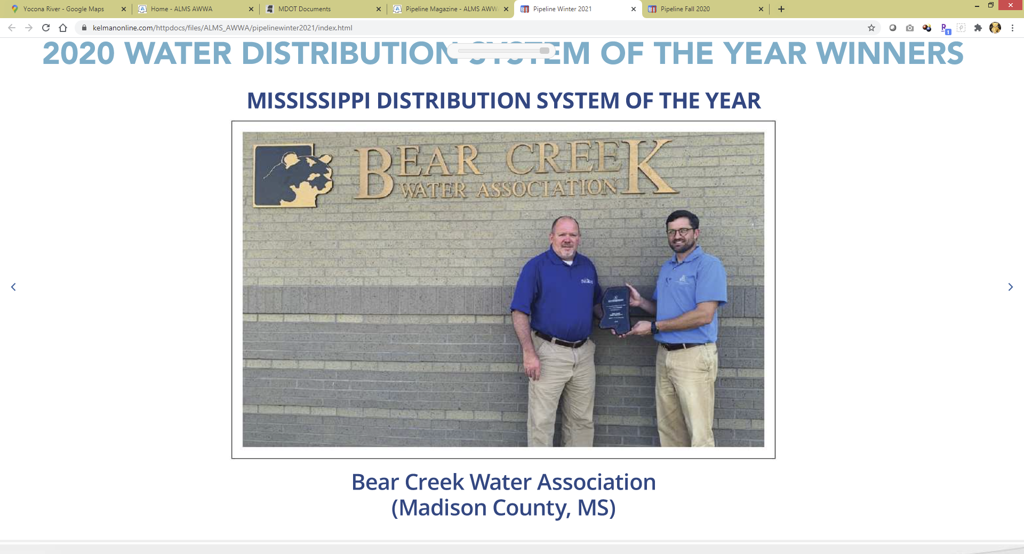

**Water Treatment Plant of the Year Award 2021 Requirements**

***Alabama/Mississippi Section of AWWA***

**Procedure:**

The Committee will receive applications until **May 31, 2021**. The **ENTIRE** application **cannot** exceed **10** pages otherwise **penalty points** will be **deducted**. Following the application deadline, the Committee may evaluate each applicant through requests for additional information and/or an evaluation of the plant by way of a site visit. The Committee shall make their own selection, using their best judgment of the nominated plant, based on additional information requested and/or the evaluation completed while visiting the plant. The award shall be presented at the **2021 AL-MS Water Joint Annual Conference.**

**Purpose:**

The Awards Committee is charged with the selection of one treatment plant from Alabama AND one from Mississippi whose outstanding performance during the preceding year merits special recognition by the Section. Recipients of the award will have demonstrated proficiency in providing exceptional quality drinking water to its customers, through the practices of utilizing efficient O&M procedures; use of labor, materials, equipment; personnel training programs; and innovative methods to maintain or improve the overall condition of the plant to minimize health hazards.

**Eligibility:**

In order for your Utility to qualify for the **Water Treatment Plant of the Year Award**, it must meet the following minimum requirements:

* The Utility OR an employee of the utility must be a member in good standing with the AL/MS Section of AWWA.
* The Utility must be in compliance with all regulatory agencies.
  + points will be deducted for water quality violations.

**Treatment Plant Evaluation Criteria**

Treatment Plants will be graded on the criteria below. Site visits may be required for obtaining portions of the criteria listed below. Please remit the following information in essay form or a brief description for consideration. Pictures may be attached as deemed necessary. Additional pages may be added to the application as needed. However, the **ENTIRE** application **cannot** exceed **10** pages otherwise **penalty points** will be **deducted**.

* Performance Measures (including, but not limited to, overall water quality; optimization and improvements implemented; O&M activities; energy efficiency; NOVs recorded; conformance to regulatory/permit requirements)
* Operational Recordkeeping / Regulatory Compliance
* Facility Maintenance Program
* Operator Training Program
* Safety Program / Safety Guidelines
* Plants Instrumentation and Calibration
* Facility Appearance
* List of Milestones or Accomplishments in the past year

**2020 WATER TREATMENT PLANT OF THE YEAR WINNERS**

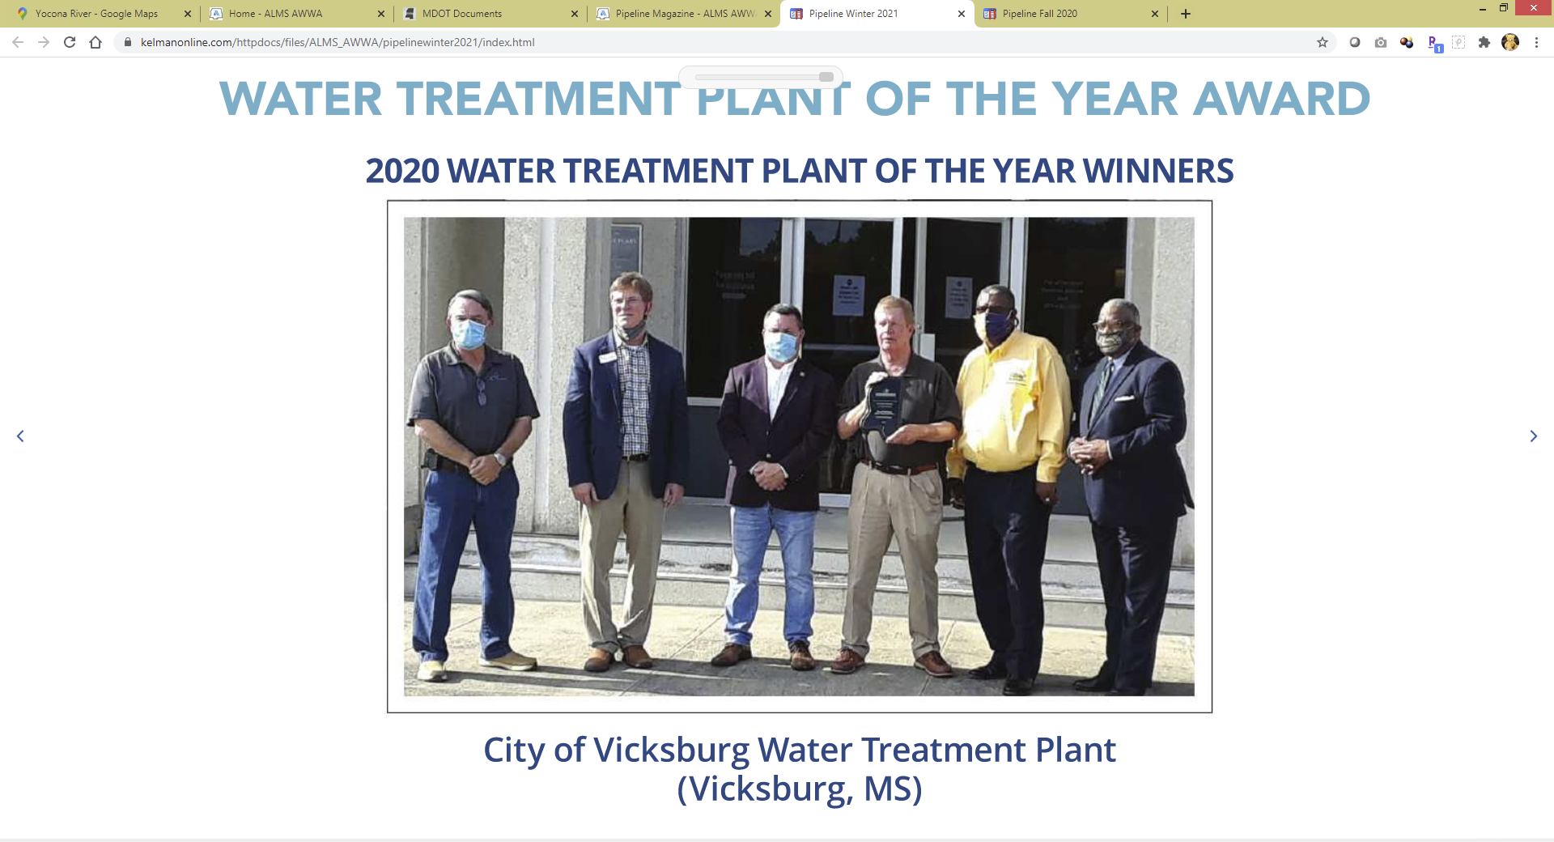

***Alabama/Mississippi Section of AWWA***

**Operator of the Year Award 2021 Requirements**

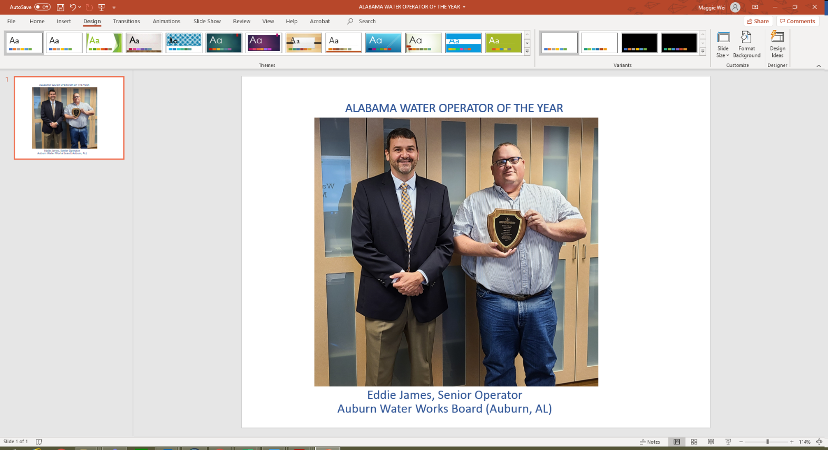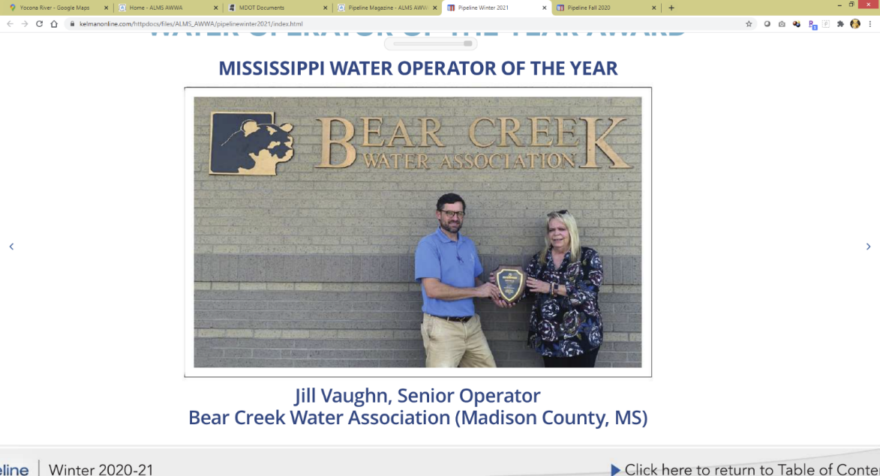

**Operator Evaluation Criteria**

Operators will be graded on the information provided in the application along with to accomplishments in the following areas:

* Continuous compliance with public health standards in finished water.
* Consistent and outstanding contribution to plant maintenance thereby prolonging the useful lives of equipment.
* The development of new and/or modified equipment or significant process modifications to provide for a more efficient or effective treatment.
* Special efforts in the training of treatment plant operators.
* Special acts not directly related to water treatment but which demonstrate dedication to the public beyond the normal operating responsibilities.
* Consistent and outstanding contribution to operation and/or maintenance of distribution lines, pump stations, and reservoirs.

**Procedure:**

The Committee will receive applications until **May 31, 2021.** the Committee may evaluate each applicant through requests for additional information. The Committee shall make their own selection, using their best judgment of the nominated operator. The award shall be presented at the **2021 AL-MS Water Joint Annual Conference.**

**Purpose:**

The Awards Committee is charged with the selection of one operator from Alabama and one from Mississippi whose outstanding performance during the preceding year merits special recognition by the Section.

**2020 OPERATOR OF THE YEAR WINNERS**

**Eligibility:**

In order for an Operator to qualify for the **Operator of the Year Award**, the nominee must meet the following minimum requirement:

* The Operator must be a member OR employed by a member Utility, in good standing with the AL/MS Section of AWWA.

**Eligibility:**

In order to qualify for the **Young Professional of the Year Award**, the nominee must meet the following minimum requirements:

* The Nominee must be under 35 years of age OR have less than 10 years of experience in the water industry.
* The Nominee must be a member OR employed by a member utility/company, in good standing with the AL/MS Section of AWWA.

**Purpose:**

The Awards Committee is charged with the selection of one young professional from Alabama and one from Mississippi whose outstanding performance during the preceding year merits special recognition by the Section.

**Young Professional Evaluation Criteria**

Young Professionals will be graded on the information provided in the application but not limited to:

* Accomplishments which entitle him/her to receive this award
* Education/Certifications
* Professional Awards or Honors received
* Community/Civic Contributions

**Procedure:**

The Committee will receive applications until **May 31, 2021.** Following the application deadline, the Committee may evaluate each applicant through requests for additional information. The Committee shall make their own selection, using their best judgment of the nominated young professional. The award shall be presented at the **2021 AL-MS Water Joint Annual Conference.**

**Young Professional of the Year Award 2021 Requirements**

***Alabama/Mississippi Section of AWWA***

**2020 YOUNG PROFESSIONAL OF THE YEAR WINNERS**

